Long Term trading starts and ends with Fibo Flip.
The DB and SAR are used on Daily and 2hr charts for Long Term Trading.
Keys to entries are with the Fibo highs and lows ( the "0" point ).
Long term trading is from the top of the Fibo to the bottom and visa versa.
Trade around 2-3% of account balance in order to compound trades.
We use SAR to compound trades by adding funds to the trade.
Suggested to move to BE after 60 pips.
One thing to be aware of before long term trading is to make sure 1hr and 2hr are in sync.
Do not use 2hr for enties and Daily for target. This will not work.
Once the setup is correct then the target is top or bottom of the Fib. Write this target level down and if it is less than 100 pips then this is still the target.
Trading DB and SAR is for trend and consolidation. In consolidation follow DB from high to low or low to high. In trend from high to low or low to high with SAR breaking off from DB for entries back into trend.
SAR is usually first to attach at "0" fib top or bottom.
SAR stands for "stop and reverse".
PSAR stands for "parabolic stop and reverse".
SAR will attach in stone with a candle retracing to PSAR support or resistance, according to trend.
The retrWhen SAR is separated from DB SAR will reattach with DB at the bottom of a candle in downtrend and the top of a candle on uptrend.
Use this info for entries on trading plan.
These connections are at "0" Fib 80% of the time.ace has to be strong enough to touch or get close to PSAR to attach to the candle.

Attached Image (click to enlarge)

Attached Image
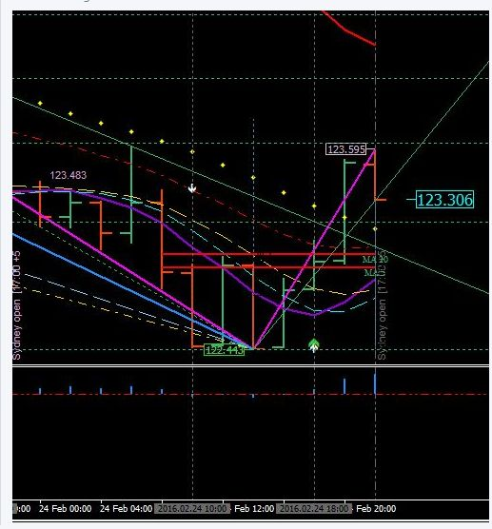

Attached Image (click to enlarge)

Attached Image
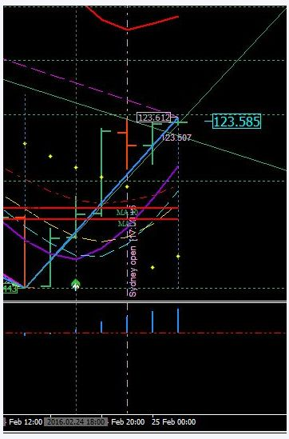

Attached Image (click to enlarge)
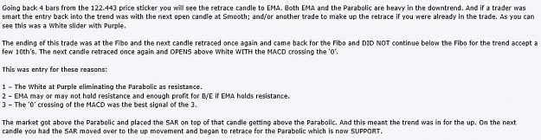

Attached Image
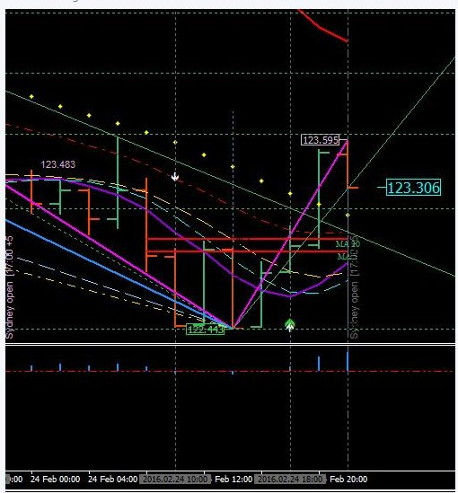

Attached Image (click to enlarge)

Attached Image
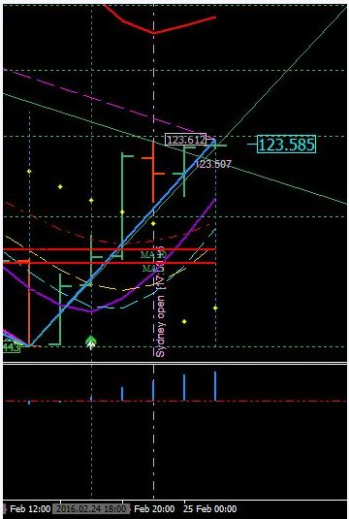

Divergences are not standard but formulated to operate outside the box.
You have Magenta for high of the Fibo with price tag and Lime Green for low of Fibo with price tag.
These are divergence for outside the box. TREND
You have Green for higher high and Gold for lower low.
These are divergence for inside the box. SWINGS
Green and Gold will attach to the top/bottom of the Fibo when market is overbought/oversold.
If Fibo does not flip it means the market is staying between high and low and consolidating between these two levels.
Attached Image (click to enlarge)
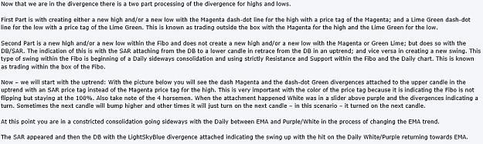

Attached Image
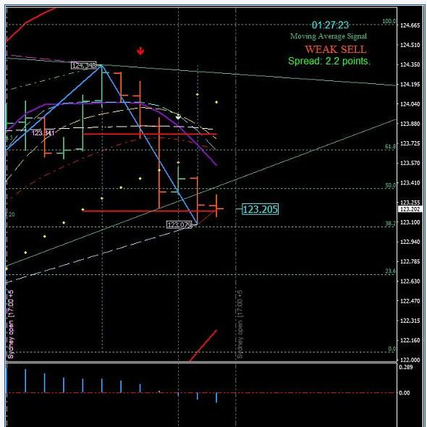

Attached Image (click to enlarge)

Attached Image (click to enlarge)
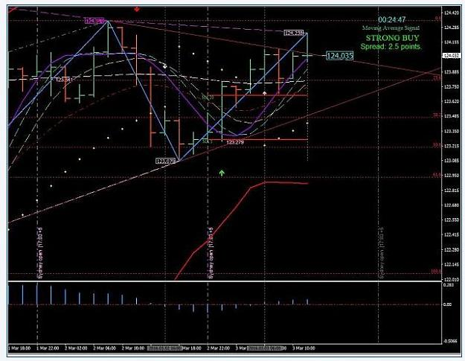

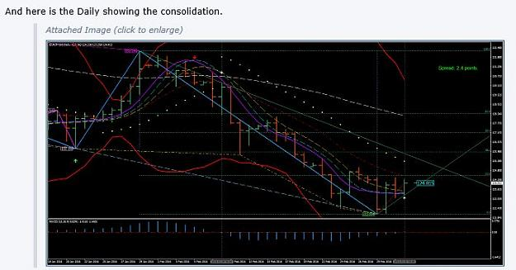

Attached Image (click to enlarge)
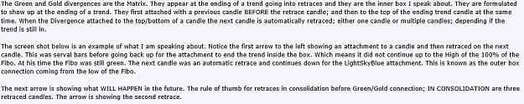

Attached Image (click to enlarge)
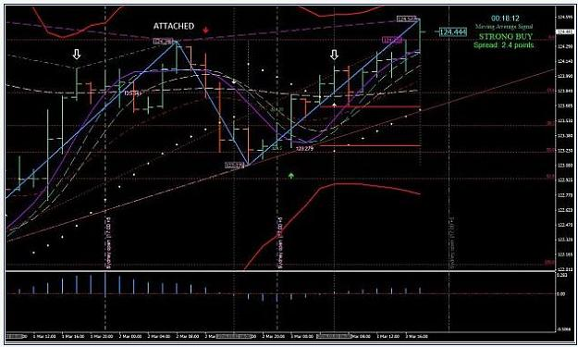
Attached Image (click to enlarge)

Attached Image (click to enlarge)
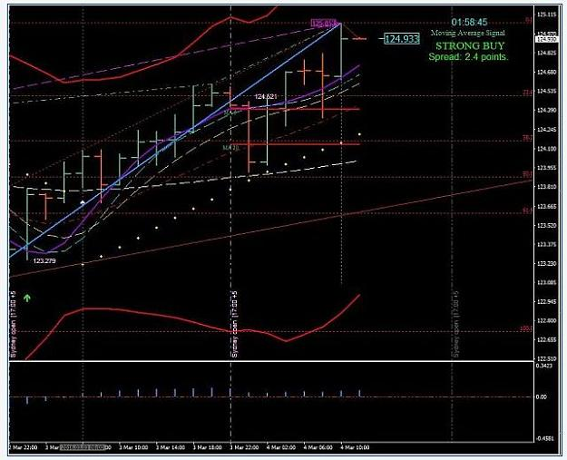
Attached Image (click to enlarge)

Attached Image (click to enlarge)
